**Enterprise Architecture Internet of Food for Cold Supply Chain**

# Identify state holder

In this project scope, we have identified three stakeholders

* Product workers: embedded the RFID (radio-frequency identification) to the seafood package
* Distribution centre manager: distribute products more effectively base on the first-expire first out strategy
* Retailer manager: who manage the products and apply business
* System administrators: who manage the application.
* Consumers: who consume the product

# Major proposed services

We have proposed these services to our application regarding to the project proposal.

* **Package details**

Product detail is will provide overall information about the product to customer. Currently, each product has consistent label which not provide enough detail for customer to understand about the product. This service will have all the digital detail about the product such as location, general product information, temperature history. The package will have the barcode that allow user to scan and visit to the website. It will give the customer have opportunity to make the best decision based on prices and temperature history. It also builds customer trust on the products.

* **Predict dynamic shelf life base temperature history**

This application will use the data analysis to instantly generate the expire data base on the defined model (the model will be defined later). It will reduce the food waste and increase the efficiency of the supplied chain.

* **Dynamic change price according the freshness of the product**

# User and use case analysis

In this section, we are going to do a detailed analysis of the user hierarchy and identify use cases for each type of user to analyse what actions can be performed by them and presented them as activity diagrams.

Further, we suggest high-level product features that can be added to user interface to enhance the user experience.

## User and description

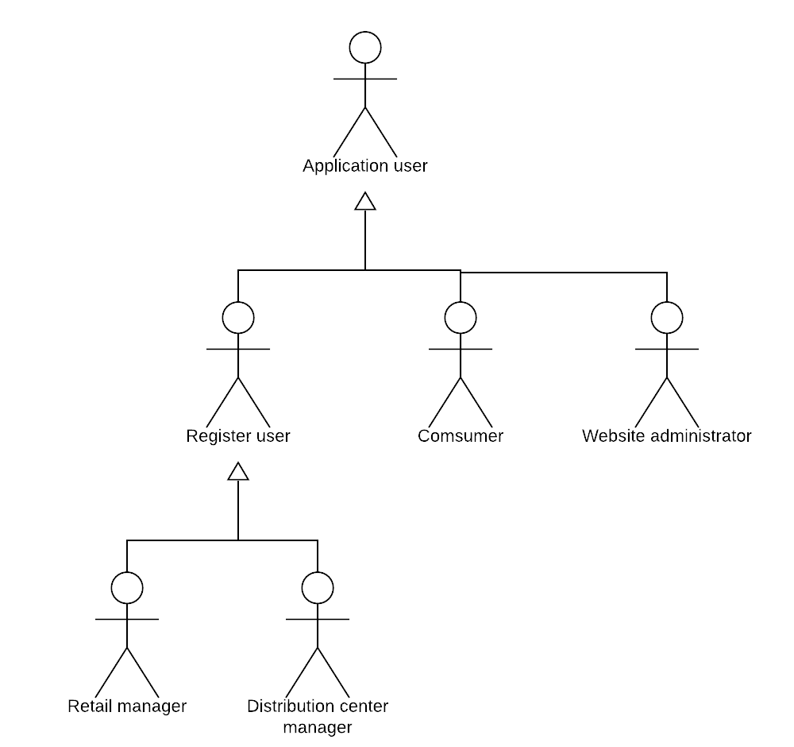

We have identified the following users as our high-level users:

* + **Website administrator** – These users have access to operational level functionalities in the application. They can also have access to the code of the application. Some of the jobs for website administrators can be solving user issues, managing website users and supervising user activities.
  + **Registered users** –This register user including retail manager and distribution centre manager. They will give the ID and signed up on the website site.
  + **Consumer** - Consumer can visit to the site by scan the bar code. The bar code will contain the product detail.

## Use case diagrams, description and activity diagram

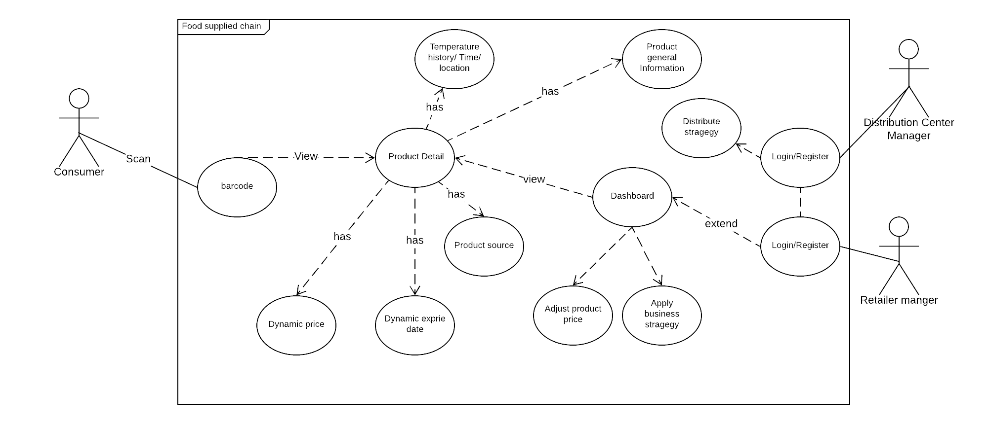

|  |  |  |
| --- | --- | --- |
| Use case name | Consumer | |
| Use Case scenario | User looking for product detail by scan the barcode in the seafood package. | |
| Use case  Triggering event | It will direct user to the website that contain the URL data parameter. It will direct user to the product detail. | |
| Scenario Description | User will able to view product comprehensive and transparency information that including   * Temperature history, time and location * Product source (where product come from) * Dynamic expire date * Dynamic price * Product general information | |
| Primary actor | User/Register User | |
| Related use cases | Consumer | |
| Pre_condition | User need to be online when they scan the product. The product information need to be available. | |
| Post condition | * Customer view product detail as list above | |
| Flow of activities | **Actor** | **Web application** |
| 1.User (consumer) go to scan the product and it will head to the web site. | 1.1. Show product that contain the barcode. There will be two functions. The first tab will have the **product general information**. The second tab will have the **temperature history**. |
| 2.If he/she click to the product general information | 2.1. The system will show   * Product source (where product come from) * Current expire date * Current price   Product general information |
| 3.If he/she click to the temperature history | 3.1. The system will show   * Temperature history on the bar chart that including date and location |

|  |  |  |
| --- | --- | --- |
| Use case name | Retailer manager interaction with the website | |
| Use Case scenario | User have the dashboard to manage the entire seafood products. | |
| Use case  Triggering event | Registered retail manager goes to the dashboard | |
| Scenario Description | User will able to view which product will expire first and which product will expire last. The expire is based on the temperature history and plus 4 days addition for the consumer. For example, today is 11 April, the product minimum expired date will from 15 April.  The user can view how many products is expire in this particular date so that they can able to manage their stock. They can also withdraw the product that already expired.  Moreover, the user can able to soft base on the criterial such as price, temperature  User can click to the particular product to view more detail | |
| Primary actor | Retail manager | |
| Pre condition | User need to be online. History temperature and product details need to be available. | |
| Post condition | * Retail manager view expired product * Retail manager can also view estimate expired time * View detail of particular product | |
| Flow of activities | **Actor** | **Web application** |
| 1.User go to food supply chain management web site. | 1.It will direct to the login/register page |
| 2. Provide credential login | 2.1. Check if the user login is valid, if it is valid, will show the dashboard. The dashboard consists of the **already expired product**, List of product **estimate expired date**. |
| 3. If user click to already expired product | 3.1. The system will list of the product that currently expired day that including shelf position that easy to withdraw. |
| 4. If the user clicks to the list of product estimate expired date | 4.1 Present all the products that estimate available in particular date. |
| 5.The user can click to view full detail about the product | 5.1 Show the full detail of product. |
| 6.Register user can logout | 6.1. Destroy the cookies/ session. |

# Propose navigation structure

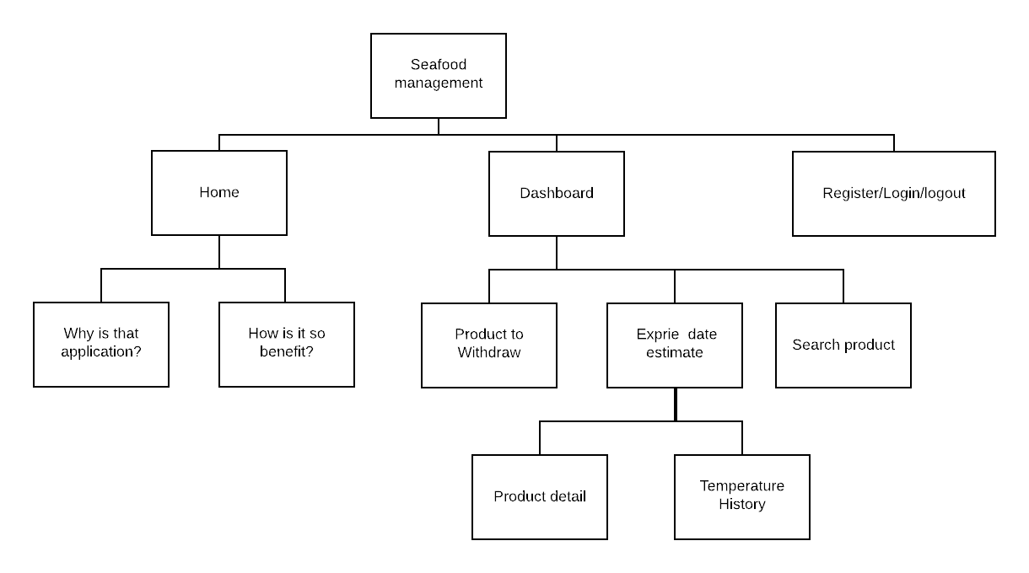

Figure 1 Manager retailer

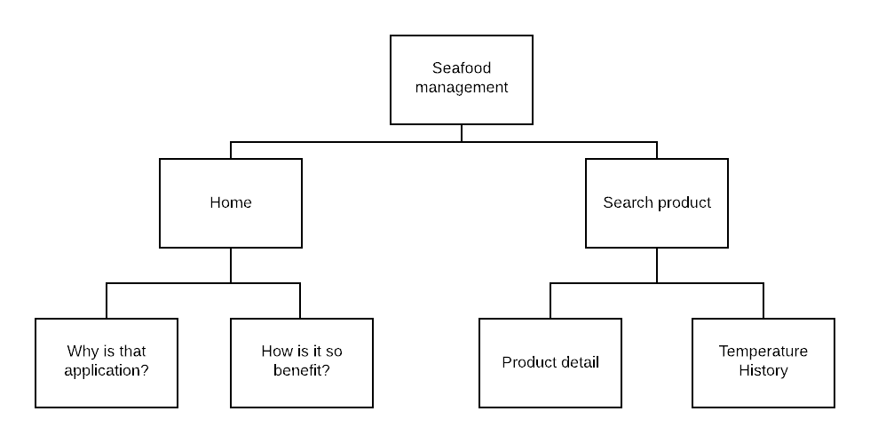

Figure 2 Consumer

# Database relationship

All the data will be analysis instantly to get the current price and estimate expire date. It will then save that metadata to the database.

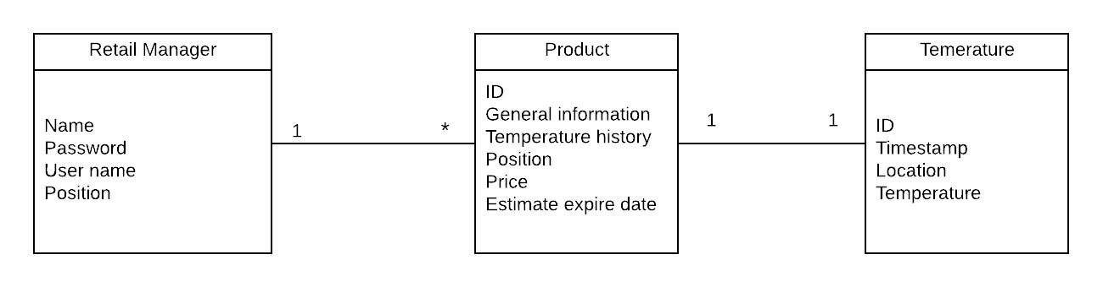

# Query to the database.

## Register

Send the request the back end that including username and password

* Check user name and password is not empty
* Check if user name already exists
* Save the user name and password to the database

## Login

Send the request to the back end that contain user name and password

* Check user name and password is not empty
* Check if user name and password is matched with the data in the database
* Create the cookie to store user information.

## Find product by ID

* Check to the database to see if the ID in the **Product** table is matched. If it is match, return all the data in this table. If the ID is not matched, return JSON file.

## Get the temperature history by ID

* Send the request that contain the ID, the **Product** table will make the join with the **Temperature** table to return all the data in the temperature table.

## Get the estimate expire date all product

* When the data sent to cloud from RFID device, we will have the current expire data store into the database.
* Send the request that list all the expired day of all product. Return the expired date.

## Get the current price (Same as 5.5 above)

## Find the product that has been expired date

* Sent the request to the database in the Product table. Select all the product that is already expired (current date + 4 days).

# Draft design

## Retail manager

# Enterprice%20architecture%20/6.1%20-%20Page%2022.png

Figure 3 login/Register

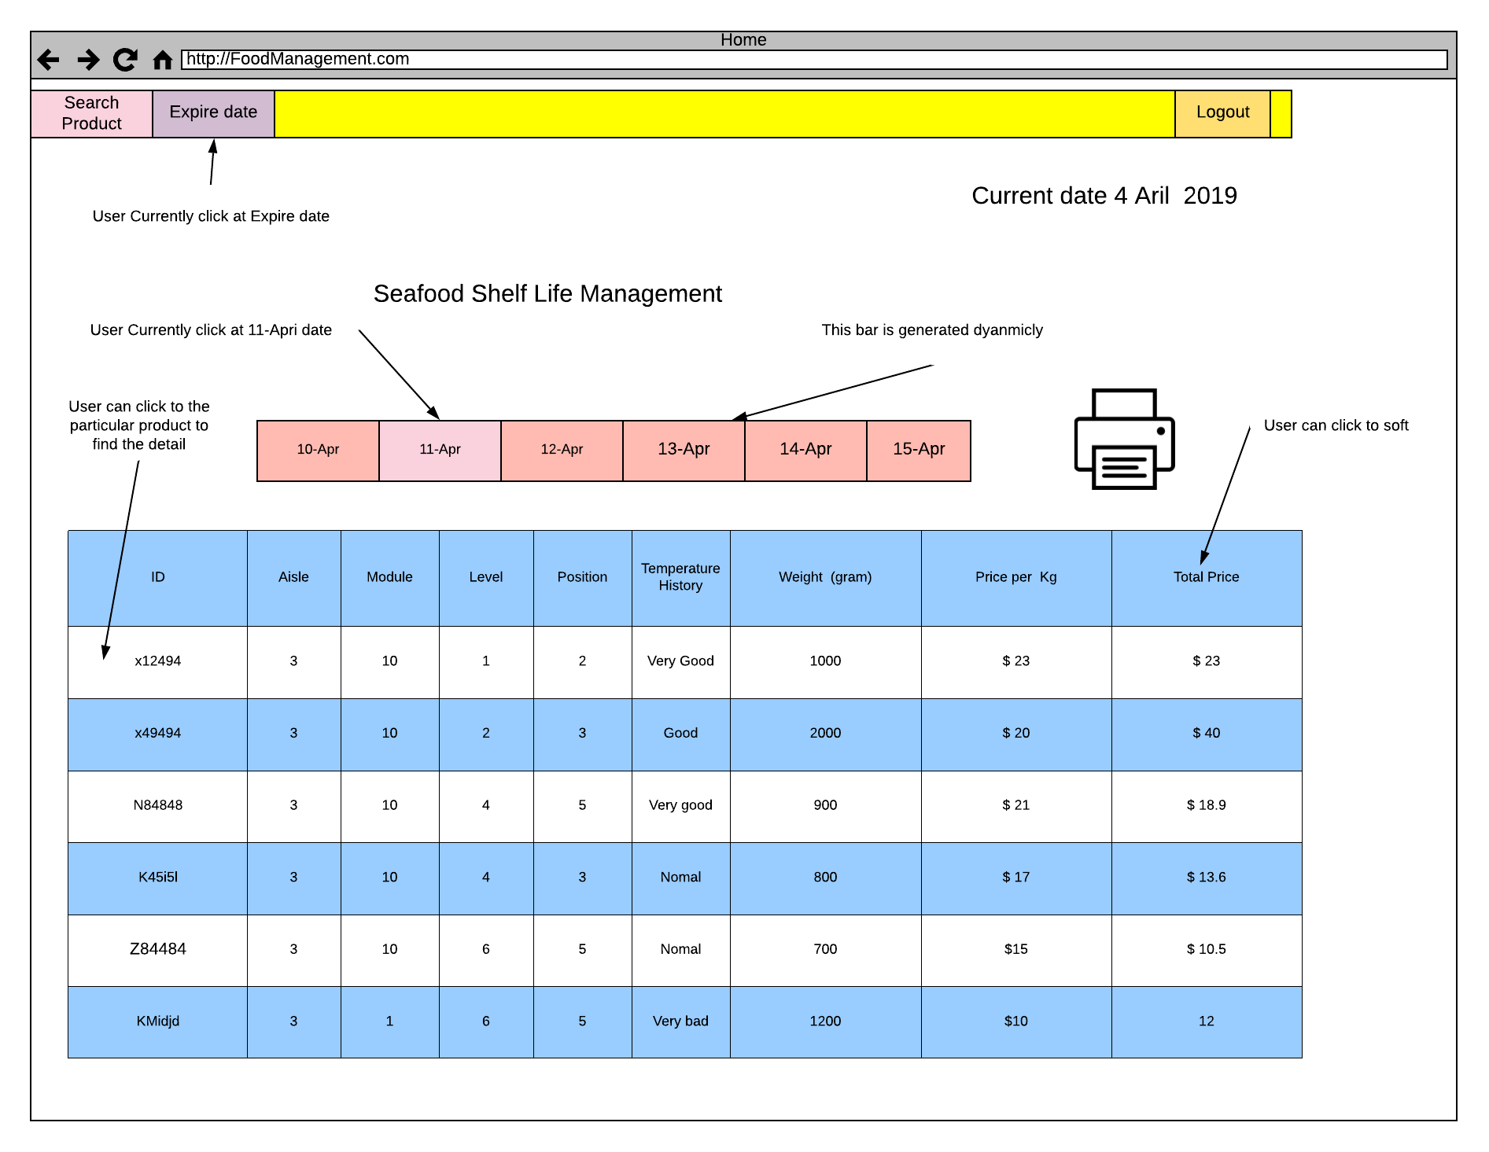

Figure 4 Dashboard

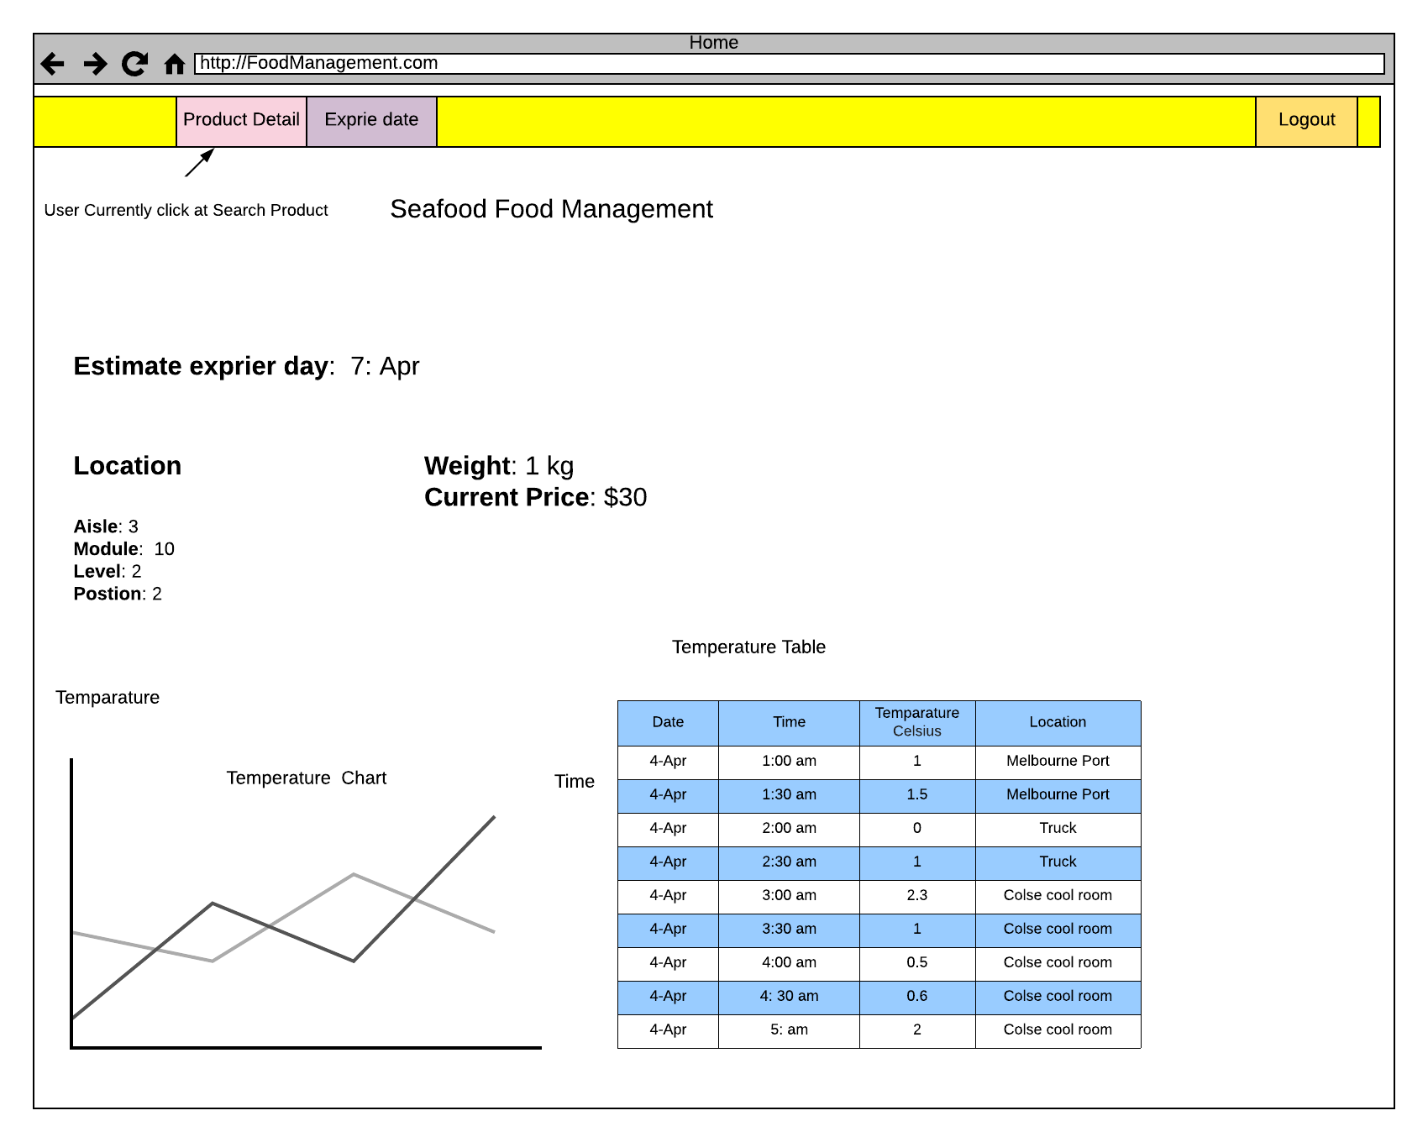

Figure 5 Dashboard detail when particular item is clicked

## Comsumer

